In main.tf file , we defined only 1 provider – local , but terrafom supports Multi-Providers in the configuration file.

We will add a new provider – random in this config file.
Random Provider – It is allow us to create random resources such as a random ID, random Integer, random Password etc.

How to use Random Provider – we will create a resource called random_pet.
This resource type will generate a random pet name when appied.

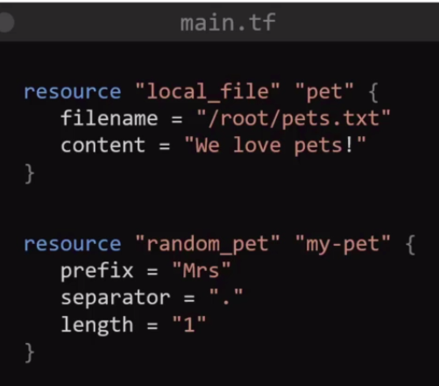
Resource 1 is local file named pets.txt will created.

Resource 2 is “random
See main.tf

resource “local_file” “pet” {
filename = “/root/pets.txt”
content = “We love pets!”
}

resource “random_pet” “my-pet” {
prefix = “Mrs”
seperator = “ . ”
length = “1”
}

Explainations:-
Here, resource “random_pet” – random is a provider
“_pet” – resource type
“my_pet” – resource name
“prefix” – This is a argument which allows you to specify a string that will separate the prefiex from generated random value by random provider.
Ex. you get random value like – Bhavin. \
You set the prefix value – Mr.

You will get out put – MrsBhavin -- Bhavin is value genetated by random provider

But, you want output like Mrs.Bhavin -- “ . ” is a seprator – see in above main.tf

Length = 1 – random value genearate only 1 word that is Bhavin

If you set length = 2 – random value generate 2 word – Ex. Bhavin.Bhavsar

